**DAR ES SALAAM INSTITUTE OF TECHNOLOGY (DIT)**

**DEPARTMENT OF COMPUTER STUDIES**

**BACHELOR OF COMPUTER ENGINEERING**

**NTA LEVEL 8**

**SENIOR PROJECT I**

|  |  |  |
| --- | --- | --- |
| **PROJECT TITLE** | **:** | **SMART GAS LEAKAGE DETECTOR AND ALERT SYSTEM** |
| **PROJECT TYPE** | **:** | **PROBLEM-SOLVING** |
| **NAME OF CANDIDATE** | **:** | **ALPHA LUCAS CHALE** |
| **REGISTRATION NO.** | **:** | **180230220519** |
| **CLASS** | **:** | **BENG19COE** |
| **SUPERVISOR NAME** | **:** | **JOSEPH CHAKUMBA** |
| **ACADEMIC YEAR** | **:** | **2022/2023** |

# **DECLARATION**

I, **ALPHA LUCAS CHALE** declare to the best of my knowledge that the project presented here, as a partial fulfillment of a Bachelor’s Degree in Computer Engineering, is my work and has not been copied anywhere or presented elsewhere.

|  |  |  |
| --- | --- | --- |
| **CANDIDATE NAME** | **SIGNATURE** | **DATE** |
|  |  |  |
| ALPHA LUCAS CHALE |  |  |
|  |  |  |
|  |  |  |
|  |  |  |
| **SUPERVISOR NAME** | **SIGNATURE** | **DATE** |
|  |  |  |
| JOSEPH CHAKUMBA |  |  |

# **ABSTRACT**

Gas leakage is a major concern at homes, offices, industries, etc. Many homes and industries had fallenvictim of inan ferno due to unknown Gas leakage at a hidden point. This is dangerous and requires high security to avoid life and property being destroyed.

One of the preventive measures to avoid the danger associated with gas leakage is to install a gas leakage detector at vulnerable locations, hence SMS-based system is proposed. The system is designed to prevent loss/death to occur through gas leakages and hence promote safety of life and property.

The main aim of the project is to design and implementation of Industrial/Homes Gas Leakage Monitoring and Detection Alarm System and SMS alerts. This will enable the user to take precaution of explosion disaster which may result on Liquefied Petroleum Gas (LPG) and other combustible gases like loss of properties, injury or even death. GLDS provides ideal solution to gas leakage problems faced by home owners in daily life.

# **ACKNOWLEDGMENT**

First and foremost, I would carefully like to take this valuable opportunity to thank Almighty God, the creator of this world and all within it, for the gift of life, strength, and wisdom during the whole time of working on this project.

My sincere gratitude and acknowledgment go to my supervisor Mr. Joseph Chakumba for his remarkable moral and intellectual support throughout my studies. His outstanding suggestions, cooperation, professional guidance, and constant encouragement have helped me a lot in the accomplishment of this project.

I am grateful to the staff members of the Computer Studies Department at Dar es salaam Institute of Technology for providing me with support during the whole period of my project work.

I, also express my special thanks again to my project coordinator, Ms. Happyness Munissi for spending her time guiding and helping me in knowing all the principles concerning with project as well as exposing the weaknesses of my project so as to make this project successful.

Last but not least, I am deeply grateful to my beloved parents, siblings, relatives, and friends for their endless and unconditional love, prayers, and support throughout my study duration so far.

**Table of Contents**

**DECLARATION** i

**ABSTRACT** ii

**ACKNOWLEDGMENT** iii

**LIST OF ABBREVIATIONS** v

**LIST OF TABLES** vi

**CHAPTER ONE** 1

**INTRODUCTION** 1

**1.** **BACKGROUND INFORMATION** 1

**1. 1 PROBLEM STATEMENT** 1

**1.2 OBJECTIVES** 2

**1.2.1 MAIN OBJECTIVE** 2

**1.2. 2 SPECIFIC OBJECTIVE** 2

**1.3 SIGNIFICANCE OF THE PROJECT** 2

**1.4 SCOPE OF THE PROJECT** 3

**CHAPTER TWO** 4

**LITERATURE REVIEW** 4

**2.1** **RELATED WORKS** 4

**2.2 EXISTING SYSTEM** 5

**2.3 PROPOSED SYSTEM** 6

**2.3.1 COMPONENTS OF PROPOSED SYSTEM** 7

**CHAPTER THREE** 9

**METHODOLOGY** 9

**3.** **INTRODUCTION** 9

**3.1 DEVELOPMENT METHODOLOGY** 9

**3.1.2 ADVANTAGES OF USING PROTOTYPING METHODOLOGY** 11

**3.1.3 DISADVANTAGES OF USING PROTOTYPING METHODOLOGY** 12

**3.2 DATA COLLECTION** 12

**CHAPTER FOUR** 14

**CONCLUSION AND RECOMMENDATION** 14

**4.0 CONCLUSION** 14

**4.1 RECOMMENDATION** 14

**4.3 PROJECT COST ESIMATIONS** 15

**4.4 ESTIMATED TIMELINE** 15

**REFERENCE** 16

**APPENDIX A:** 17

**LIST OF ABBREVIATIONS**

|  |  |
| --- | --- |
| **SHORT FORM** | **ABBREVIATION** |
| GSM | Global System for Mobile Communications |
| IoT | Internet of Things |
| LCD | Liquid crystal display |
| LPG | Liquefied petroleum Gas |
| MCU | Microcontroller unit |

# **LIST OF TABLES**

Table 1: Project Cost Estimation 15

Table 2: Estimated Timeline 15

**LIST OF FIGURES**

Figure 1: Existing System 5

Figure 2: Proposed system 6

Figure 3: Diagram Of Prototyping Methodology 9

# **CHAPTER ONE**

## **INTRODUCTION**

### **BACKGROUND INFORMATION**

In Tanzania, gas is widely used for cooking and heating purposes, particularly in urban areas. The use of gas has increased rapidly in recent years due to its accessibility, affordability and efficiency. However, with the increase in the use of gas, the risk of gas leaks has also increased, posing a significant threat to public safety.

Gas leaks are caused by a variety of factors, including corrosion of pipes, faulty appliances, and human error. Gas leaks can cause health problems, fires, and explosions, which can result in loss of life and property. In many cases, gas leaks go unnoticed until it's too late, which is why a gas leakage detection and alert system is crucial.

Currently, the methods of gas leakage detection in Tanzania are manual and unreliable. Individuals rely on their senses to detect gas leaks, which is not always effective. In addition, the response times are often slow, which can lead to serious consequences.

The need for a gas leakage detection and alert system in Tanzania is clear. A system that can detect gas leaks quickly and accurately, alert individuals and emergency services, and prevent potential disasters would greatly improve public safety and increase the confidence of the community in the use of gas for cooking and heating purposes.

Implementing a gas leakage detection and alert system in Tanzania requires significant investment and resources. The system should be designed to meet the specific needs of the local market, including affordability, ease of installation, and maintenance. The government, private sector, and non-government organizations should collaborate to ensure the success of this project

### **1 PROBLEM STATEMENT**

In Tanzania, gas leakage is a major concern that can cause health problems, fires and explosions. With the increasing use of gas for cooking and heating purposes, the risk of gas leakage has become more significant. In many cases, gas leaks go unnoticed until it's too late, resulting in serious consequences.

The problem is that there is a lack of an effective and reliable system to detect and alert individuals of gas leaks in Tanzania. The current methods of detection are unreliable and manual, which can lead to missed leaks and delayed response times. This puts the lives of individuals and the community at risk.

The need for a gas leakage detection and alert system in Tanzania is urgent. The system should be able to detect gas leaks in real-time, alert individuals and emergency services, and prevent potential disasters. It should be affordable, easy to install and maintain, and provide accurate and timely alerts.

The solution to this problem is the development and implementation of a gas leakage detection and alert system in Tanzania. The system should be able to detect gas leaks quickly and accurately, alert individuals and emergency services, and prevent potential disasters. This will not only improve the safety of individuals but also increase the confidence of the community in the use of gas for cooking and heating purposes.

### **OBJECTIVES**

The objectives of this project proposal are divided in two parts namely, main and specific objectives.

### **1.2.1 MAIN OBJECTIVE**

The main objective of the project is to design and implement a smart gas leakage detector system

### **1.2. 2 SPECIFIC OBJECTIVE**

1. To design a software simulation circuit for the gas leakage detection.
2. To analyze and detect gas leakage with the help of sensors.
3. To design a subsystem of sound alarm that will produce sound alert on gas detection
4. To design a subsystem that will provide alert notification SMS.
5. To design a subsystem that will clear the leaked gas

### **1.3 SIGNIFICANCE OF THE PROJECT**

1. **Improved public safety**: A reliable gas leak detection system can help prevent accidents and protect the public from harm.
2. **Environmental protection**: Early detection of gas leaks can help prevent environmental damage, such as soil and water pollution.
3. **Economic benefits**: By reducing the frequency and severity of gas leaks, the project can help save resources and reduce economic losses.
4. **Compliance with regulations**: Implementing a gas leak detection system can help ensure compliance with local and national regulations, protecting the reputation of the industry and avoiding fines.
5. **Increased efficiency**: A gas leak detection system can improve the efficiency of gas distribution and reduce waste, helping to maximize resources and minimize costs.

### **1.4 SCOPE OF THE PROJECT**

The scope of the gas leakage detection and alert system will include the following aspects: Detection and monitoring: The system will have sensors that can detect gas leaks in real-time and alert individuals and emergency services. The sensors will be placed strategically for comprehensive coverage and accurate detection.

Alerts and notifications: The system will provide alerts and notifications through multiple channels such as SMS, email, and a mobile app to ensure quick and effective response.

Data management and analysis: The system will collect and store data on gas leaks, which will be analyzed to identify trends and areas for improvement.

User interface: The system will have a user-friendly interface for individuals to monitor gas leaks and respond to alerts. It will also provide relevant information and instructions.

Affordability and accessibility: The system will be designed to be affordable and accessible, making it accessible to a wide range of individuals and businesses. It will be easy to install and maintain, reducing the cost and time required.

Local production and support: The system will be designed and manufactured locally, promoting local capacity and reducing dependence on imported technologies. Ongoing maintenance and support will be provided to ensure its effective functioning.

Awareness and education: Awareness and education campaigns will accompany the system to promote safe gas use and educate the public on how to respond to gas leaks and alerts

# **CHAPTER TWO**

## **LITERATURE REVIEW**

### **RELATED WORKS**

Komiyama et al.(2003) presented a gas leakage detection system detecting leakage of plurality of kinds of gases by analysing components of a sampled gas and means for determining that at least one kind of specific gases when is included in the sampled gas is equal to one or more than predetermined quantity as a result of analysis. By analysing means, a gas leakage detection method of monitoring an operating state by eliminating a harmful substance included in a plurality of gases that leak and a semiconductor apparatus having a gas detection system that detects a leakage of plurality of kinds of gases.

In their paper, Saidi et al. (2008) proposed a method of detecting concentration of predetermined gas, a gas sensor comprising a gas detector, a processor to determine a rate of change of the concentration over a time interval and a communication device to communicate to at least one of a second gas detector and a server.

Yoshida (2009) explores fuel battery system comprising of a fuel battery to which a reactive gas is supplied to generate power, a pipe which communicates with fuel battery and a method of detecting a gas leakage in the fuel battery system. The major task was to improve performance.

In their paper Yokosawa et al. (2008) suggested leakage detection system configured by a number of gas sensors; leakage spot is promptly and accurately estimated. An output voltage of each sensor is converted into concentration and a time differential output of concentration

The above related works focused on different approach to monitor and control environmental conditions in poultry houses, but most of them were not integrated with GSM technology and Teal time clock to control devices such as lighting with accurate time stamps. Therefore this project will fill that gap by incorporating GSM technology and Real time clock in monitoring and control of poultry houses.

### **2.2 EXISTING SYSTEM**

The existing gas leakage detection system is based on the traditional gas detectors which are installed in homes, offices and industrial areas to detect gas leaks. These detectors are designed to detect gas leaks and trigger an alarm when gas concentration exceeds a certain level.

The existing system of gas leakage detection system it only use alarms for warning. There is nothing about protection once the leaked gas as it may lead into explosion and cause severe damage to life and environment.

However, these systems have a number of limitations such as false alarms, limited coverage, and limited communication with the control room.

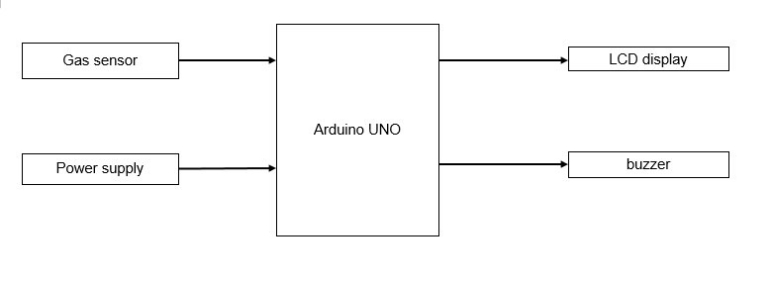

Figure 1: Existing System

#### **2.2.1 LIMITATION OF EXISTING SYSTEM**

The existing gas leakage detection system has several limitations, including:

1. False Alarms: Traditional gas detectors are prone to false alarms due to factors such as dust, humidity, and temperature fluctuations. This leads to inconvenience and may also result in evacuation and downtime.
2. Limited Coverage: The traditional gas detectors only cover a limited area and are not capable of detecting gas leaks in hidden or inaccessible areas.
3. Lack of Integration: The existing gas detectors are standalone units and are not integrated with other systems, making it difficult to monitor gas leaks in real-time.
4. Limited Communication: The traditional gas detectors do not have a direct communication system with the control room, making it difficult to respond to gas leaks in a timely manner.
5. Maintenance Issues: The traditional gas detectors require regular maintenance to ensure they are functioning properly, which increases the operational costs.

These limitations of the existing system make it less effective in detecting gas leaks and responding to them in a timely manner, leading to increased safety risks

### **2.3 PROPOSED SYSTEM**

The proposed system is a smart gas leakage detection and alert system that uses Internet of Things (IoT) technology to provide a more efficient and reliable solution. This system consists of multiple sensors installed in different areas to detect gas leaks.

These sensors are connected to a central control unit through a wireless network, which enables real-time monitoring of gas concentrations. The central control unit analyzes the data from the sensors and sends alerts to the control room if a gas leak is detected.

The system also sends notifications to designated users via email or SMS. This system provides a more accurate and efficient solution compared to traditional gas detectors and eliminates the limitations of the existing system.

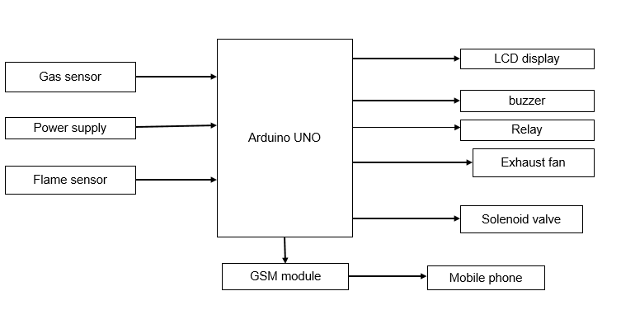

Figure 2: Proposed system

### **2.3.1 COMPONENTS OF PROPOSED SYSTEM**

The main components of gas leakage detection and alert system include:

1. **Microcontroller(Arduino Uno)**

Arduino Uno is a microcontroller board based on the ATmega328p. It has 14 digital input/output pins (of which 6 can be used as PWM outputs), 6 analog inputs, a 16 MHz crystal oscillator, a USB connection, a power jack, an ICSP header, and a reset button. It contains everything needed to support the microcontroller; simply connect it to a computer with a USB cable or power it with a AC-to-DC adapter or battery to get started

1. **Sensors**

The MQ6 is a simple-to-use liquefied petroleum gas (LPG) sensor. It can be used in gas leakage detecting equipment in consumer and industry applications, this sensor is suitable for detecting LPG, iso-butane, propane, LNG. Avoid the noise of alcohol, cooking fumes and cigarette smoke. The sensitivity can be adjusted by the potentiometer. The MQ-6 can detect gas concentrations anywhere from 200 to 10000ppm. This sensor has a high sensitivity and fast response time.

1. **Buzzer**

A buzzer is a mechanical, electromechanical, magnetic, electromagnetic, electro-acoustic or piezoelectric audio signaling device. We are using electromagnetic buzzer in our project. The vibrating disk in a magnetic buzzer is attracted to the pole by the magnetic field. When an oscillating signal is moved through the coil, it produces a fluctuating magnetic field which vibrates the disk at a frequency equal to that of the drive signal

1. **GSM module**

GSM is a cellular network, which means that cell phones connect to it by searching for cells in the immediate vicinity. This is a GSM/GPRS-compatible Quad-band cell phone, which works on a frequency of 850/900/1800/1900MHz and which can be used not only to access the Internet, but also for oral communication (provided that it is connected to a microphone and a small loud speaker) and for SMS

1. **LCD display**

The LCD display is used to display the data collected by the sensors and the status of the various devices and systems in the poultry house.

1. **Power supply**

A power supply unit is used to provide power to the system. This can be a battery or a mains power supply.

1. **Communication module**

A communication module may be added to the system to enable communication between the microcontroller and other devices, such as user's mobile phone, the communication module used includes GSM.

1. **DC Motor**

A DC motor uses electrical energy to produce mechanical energy, very typically through the interaction of magnetic fields and current-carrying conductors. The DC motor has two basic parts: the rotating part that is called the armature and the stationary part that includes coils of wire called the field coils. The stationary part is also called the stator.

# **CHAPTER THREE**

## **METHODOLOGY**

### **INTRODUCTION**

In system development processes, Methodology is a systematic, theoretical analysis of the methods applied to a field of study. It comprises the theoretical analysis of the body of methods and principles associated with branch knowledge. Basically, methodology deals with strategies on how to accomplish a project. For project objectives to be achieved, I employed prototyping-based methodology because it allows changes of user requirement during the development of the project and also perform system analysis, system design and system implementation concurrently.

### **3.1 DEVELOPMENT METHODOLOGY**

Prototyping based methodology is oriented in developing a working model of the product and correcting it according to user suggestions before releasing the final product. The analysis design and implementation phases are done repeatedly until the system is complete. The following is the block diagram of prototype methodology.

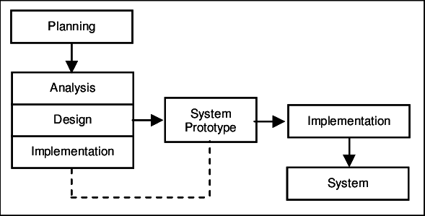

Figure 3: Diagram Of Prototyping Methodology

#### **3.1.1 PHASES OF PROTOTYPING METHODOLOGY**

This section describes what is done in each phase and which tool is used in the corresponding phase.

**PLANNING**

In this phase all the activities which take place during development will be known start from generating new idea concerning gas leakage detection and alert system and knowing all requirement which will be used to produce the final result. This phase includes knowing all the procedures on how to implement poultry house monitoring and control system.

**ANALYSIS**

This phase deals with requirements modelling. Requirements include functional and non-functional requirements. In this phase requirements are collected by using both questionnaire and interview based consumers of the gas and experts in order to deliver the system requirements document that describes management and user requirements, cost and benefits and alternative development strategies

**SYSTEM DESIGN**

Design phase deals with creating physical models that satisfy all the requirements documented for the system. The design phase decides how the system will operate, in terms of the hardware and software. Although most of the strategic decisions about the system were made in the development of the system concept during the analysis phase, the design phase determines exactly how the system will operate. In my project I will demonstrate a hardware using an electronic device, mechanical devices tools and equipment. And also, in case of software I will develop a simulation circuit for gas leakage detection and alert system and its software using Proteus or Arduino IDE as programming language.

**BUILDING A PROTOTYPE**

In this phase I will build the prototype which is not different from the final product so as to acquire feedback from the customer if there is a little correction concerning the prototype so as to get the complete better product.

**USER EVALUATION**

This is the stage of prototyping model where the user is given the prototype to use it and provide the necessary collections, so as to be added or what to be removed so as to make the best final project. If the feedback is positively, then the product can be implemented though most of the time, the feedback about adding or removing something is inevitable.

**PROTOTYPE REFINING**

If recommended by the user the prototype can be refined to satisfy user needs, this may involves redesigning the system and present to the user again for evaluation. In this stage, the feedback from the user is worked upon so as obtain the complete final product. It’s the time to correct errors and make sure that the next product is improved.

**COMPLETE SYSTEM**

In this phase after making the prototype several times, and modifying it until the users are satisfied, then the final system is going to be implemented and make a final thoroughly test before handling it to the user/customer so that he/she can start using it.

### **3.1.2 ADVANTAGES OF USING PROTOTYPING METHODOLOGY**

There are several advantages of using prototyping methodology in the development of a poultry house monitoring system, or any other system or product, including:

1. Allows for early testing and validation: With a working prototype, it is possible to test and validate the system's functionality and performance early on in the development process, which can help identify and address any issues or problems before they become more expensive and time-consuming to fix.
2. Facilitates communication and collaboration: A prototype can be used as a visual aid to help communicate the design and functionality of the system to stakeholders and team members, which can facilitate collaboration and feedback.
3. Increases efficiency and cost-effectiveness: By using a prototyping methodology, it is possible to quickly and inexpensively create a working model of the system, which can help identify and address issues and problems early on in the development process, ultimately saving time and money.
4. Helps identify design issues early:By creating a working prototype early in the design process, it is possible to identify and address any issues or problems with the design of the system before they become more expensive and time-consuming to fix.
5. Improves the final product: By iterating on the prototype and incorporating feedback from stakeholders and team members, it is possible to improve the final product and ensure that it meets the needs of the users.
6. **Provides a basis for further development:** A working prototype can be used as a starting point for further development and can be refined and improved in later stages of the development process.

### **3.1.3 DISADVANTAGES OF USING PROTOTYPING METHODOLOGY**

While there are many advantages to using prototyping methodology, there are also some potential disadvantages to consider, including:

1. It is very difficult for the developers to accommodate all the changes demanded by the customer.
2. Practically, this methodology may increase the complexity of the system as the scope of the system may expand beyond original plans.
3. There is uncertainty in determining the number of iterations that would be required before the prototype is finally accepted by the customer.
4. After seeing an early prototype, the customers sometimes demand the actual product to be delivered soon.
5. Developers in a hurry to build prototypes may end up with sub-optimal solutions.
6. The customer might lose interest in the product if he/she is not satisfied with the initial prototype.

### **3.2 DATA COLLECTION**

This is the process of gathering the information which would facilitate the accomplishment of the project and the data is collected from various sources using different methods including questionnaires, interview, and observation and existing records. In this phase the facts and requirements about gas leakage detection and alert system are gathered. Sources of information during the requirements discovery phase will include included gas consumers and suppliers through interview method and Questionnaire method.

#### **3.2.1 INTERVIEW**

Interviews is a method of data collection that is designed to collect a richer source of information from a small number of people about opinions, attribute, preferences as well as knowledge. Interview was one of the methods used for requirements gathering.

**Reason for using interview on this project:**

1. Most data collection questions in this project are open ended.
2. Sample is small.
3. Interview will provide more room for the conference center owners to explain their answers.
4. The interviewer can control over the order of the question, as in the questionnaire, and can judge the spontaneity of the respondent as well.
5. The interview has a better response rate than mailed questions, and the people who

cannot read and write can also answer the questions.

1. The interviewer can usually control which person(s) will answer the questions.

#### **3.2.2 QUESTIONNAIRE**

A list of questions or items used to gather data from respondents about their attitudes, experiences, or opinions. Questionnaires can be used in gas leakage detection and alert system, to gather data from all gas consumers who use it as a source of energy, the challenges they face, and their requirements and preferences for gas leakage detection.  
**Reason for using a questionnaire on this project:**

1. Anonymous and suitable for sensitive topics allowing respondents to provide honest and candid responses without fear of repercussions.
2. Provides the possibility to reach a large number of respondents in a relatively short period of time.

# **CHAPTER FOUR**

## **CONCLUSION AND RECOMMENDATION**

This is the last chapter in this report. It gives out the overall summary of the project done. It includes conclusion and recommendations about the project.

### **4.0 CONCLUSION**

In conclusion, the gas leakage detection and alert system is a critical tool for ensuring safety in facilities that handle flammable gases. The existing gas leakage detection systems have certain limitations, and data collection through interviews and questionnaires has provided valuable insights into the needs and requirements of the users.

Based on the data collected, the proposed gas leakage detection and alert system should be designed to provide real-time monitoring, user-friendly alerts through multiple channels, integration with other systems, customizable data display, and minimal false alarms. The proposed system has the potential to greatly enhance the safety of facilities that handle flammable gases, and provide peace of mind to users in the event of a gas leak

In this system I will use prototype methodology because it is oriented in developing a working model of the product and correcting it according to user suggestion before releasing the final product. This model works best in scenarios where not all of the project requirements are known in detail thus it is a trial-and-error process between the user and the developer of the system. This methodology helps to come up with a good product. And I also I will use questionnaire and interview as methods to collect data.

### **4.1 RECOMMENDATION**

Based on our analysis of the gas leak detection and alert system needs in Tanzania, we recommend the adoption of a smart gas leak detection system that incorporates the latest sensors and algorithms to accurately detect gas leaks in real-time. This system should be equipped with automatic alert notifications through SMS, email, and app push notifications, to ensure that the relevant authorities and stakeholders are quickly informed of any gas leaks.

In addition, we recommend that the system be integrated with a backup power source, such as a generator, to ensure its continued operation even in the event of a power outage. Regular maintenance and calibration should be performed to maintain its accuracy and reliability.

Given the limited resources and infrastructure in many parts of Tanzania, we recommend that the system be designed for ease of installation and maintenance, with a focus on affordability and accessibility. By implementing these recommendations, Tanzania will be better equipped to detect gas leaks quickly and respond appropriately to minimize harm and liability."

### **4.3 PROJECT COST ESIMATIONS**

|  |  |  |
| --- | --- | --- |
| **COMPONENT** | **DESCRIPTION** | **COST** |
| TRANSPORT | DATA COLLECTION | 40,000 |
| STATIONARY | BOOK COPIES | 60,000 |
| TOTAL TOOLS COST | HARDWARE COMPONENTS | 420,000 |
| INTERNET BUNDLE | BROWSING THROUGH THE NETWORK TO OBTAIN USEFUL INFORMATION AND KNOWLEDGE | 40,000 |
| EMERGENCY | FAULT IN HARDWARE COMPONENT | 70,000 |
| **TOTAL** | | **630,000/=** |

Table 1: Project Cost Estimation

### **4.4 ESTIMATED TIMELINE**

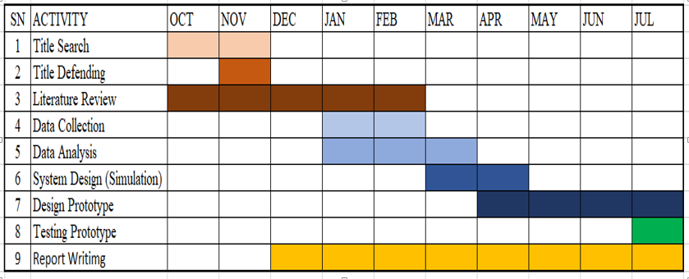

Table 2: Estimated Timeline

# **REFERENCE**

[1] Anita kulkarni, T. Ravi Teja, “Automated System for Air Pollution Detection and Control in Vehicles”, International Journal of Advanced Research in Electrical, Electronics and Instrumentation Engineering, Vol. 3, Issue 9, September 2014

[2] Vasana prathyusha, P. Bala murali Krishna “Pollution Check in Vehicles and Alerting System using Location Identifier”, International Journal of Innovative Research in Computer and Communication Engineering, Vol. 3, Issue 10, October 2015

[3] Sandip S. Patil, Jaykaran Singh, “Monitoring and Controlling of Hazardous Gases inside Vehicle and Alerting using GSM Technology for the Safety of People inside the Vehicle”, International Journal of Science, Engineering and Technology, Vol 3, Issue 1 JAN-FEB 2015

[4] D.D Mondal, Rutuja Deshpande, Pooja Bhagat, Gitanjali Bandal, “A System detecting an Air Pollution and tracking using GPS & GSM”,International Research Journal of Engineering and Technology,Volume: 04, Issue: 04, Apr -2017

[5] Chaitanya H P, H. Prasanna Kumar, “Automated System For Air Pollution Detection And Control Of Speed In Vehicles”, International Journal of Advances in Engineering & Technology,Vol. 9, Issue 4, August 2016.

# **APPENDIX A:**

Here are some sample interview questions that can be used in the context of the proposed gas leakage detection and alert system:

1. What challenges have you faced with your current gas leakage detection system?
2. What are your requirements from a new gas leakage detection system?
3. How would you describe your ideal gas leakage detection system?
4. What features do you think are most important in a gas leakage detection system?
5. Have you ever experienced a false alarm with your current system?
6. What kind of alerts would you like to receive in case of a gas leak?
7. How would you like to receive alerts (e.g. email, SMS, phone call)?
8. What kind of data would you like to see in the control room in case of a gas leak?
9. How important is real-time monitoring for you in a gas leakage detection system?
10. What are your thoughts on integrating the gas leakage detection system with other systems in your facility?

These questions can be used as a starting point for the interview and can be modified based on the specific requirements of the study. The goal of these questions is to gather detailed information from the interviewees and to understand their needs and expectations from a new gas leakage detection system

Here are some sample questionnaire questions that can be used in the context of the proposed gas leakage detection and alert system:

How often do you use your current gas leakage detection system?

1. Daily
2. Weekly
3. Monthly
4. Rarely
5. Never

On a scale of 1 to 5, how satisfied are you with your current gas leakage detection system?

1. 1-Very unsatisfied
2. 2
3. 3
4. 4
5. 5-Very satisfied

Have you ever experienced a false alarm with your current gas leakage detection system?

1. Yes
2. No

What type of alerts would you like to receive in case of a gas leak?

1. Email
2. SMS
3. Phone call
4. All of the above

How important is real-time monitoring for you in a gas leakage detection system?

1. Very important
2. Important
3. Not important

What kind of data would you like to see in the control room in case of a gas leak?

1. Gas concentration levels
2. Temperature
3. Humidity
4. Location
5. All of the above

What kind of data would you like to see in the notifications you receive in case of a gas leak?

1. Gas concentration levels
2. Temperature
3. Humidity
4. Location
5. All of the above

How important is the integration of the gas leakage detection system with other systems in your facility for you?

1. Very important
2. Important
3. Not important

These questions can be used as a starting point for the questionnaire and can be modified based on the specific requirements of the study. The goal of the questionnaire is to gather information from a larger number of participants and to understand their needs and expectations from a new gas leakage detection system.